Personal Measures
Daily Health Checks
Staff, parents and students will be regularly reminded of their responsibilities to complete a Daily Health Check and are provided with resources on how to complete one (e.g., the K-12 Health Check app).
The daily sign in will confirm the staff/visitors completion of the Health Check
- Sign in sheets are at the school entrance
- Staff will be reminded of their weekly responsibility to complete the Health Check daily via the Week at A Glance
Stay Home When Sick / What to Do When Sick
Students, staff or other adults should stay at home when sick, as this is one of the most important ways to reduce the introduction to and the spread of COVID-19 in schools. The following resources provide guidance regarding specific symptoms of illness:
- Parents/caregivers and students can use the K-12 Health Check app
- Staff and other adults can refer to BCCDC’s When to get tested for COVID-19
- Staff, students and parents/caregivers can also use the BCCDC online Self-Assessment Tool, call 8-1-1 or their health care provider.
Symptoms Develop at School
Some students or staff may not be able to be picked up immediately. Schools will have a space available where the student or staff can wait comfortably and is separated from others (at least 2M), and provide the student or staff with a mask if they do not have one.
Schools must provide supervision for younger children. Supervising staff should wear a non-medical mask and face shield if they are unable to maintain physical distance, avoid touching bodily fluids as much as possible, and practice diligent hand hygiene.
Staff responsible for facility cleaning should clean and disinfect the surfaces/equipment, which the person’s bodily fluids may have been in contact with while they were ill.

Returning to School after Illness
When a staff member, student or other adult can return to school depends on the type of symptoms they experienced (as indicated in the K-12 Health Check app and BCCDC When to get tested for COVID-19 resource, if a COVID-19 test is recommended, and the type of illness they had (e.g. COVID-19 or other illness). See Appendix A COVID-19 Symptoms, Testing & Return to School for more information regarding what to do when experiencing COVID-19 symptoms.
Students and staff who experience symptoms consistent with a previously diagnosed health condition (e.g. seasonal allergies) can continue to attend school when they are experiencing these symptoms as normal. They do not require re-assessment by a health-care provider and should not be required to provide a health-care provider note. If they experience any new or unexplained symptoms, they should seek assessment by a health-care provider.
Students or staff may still attend school if a member of their household develops new symptoms of illness, provided the student/staff has no symptoms themselves. If the household member tests positive for COVID-19, public health will advise the asymptomatic student/staff on self-isolation and when they may return to school.

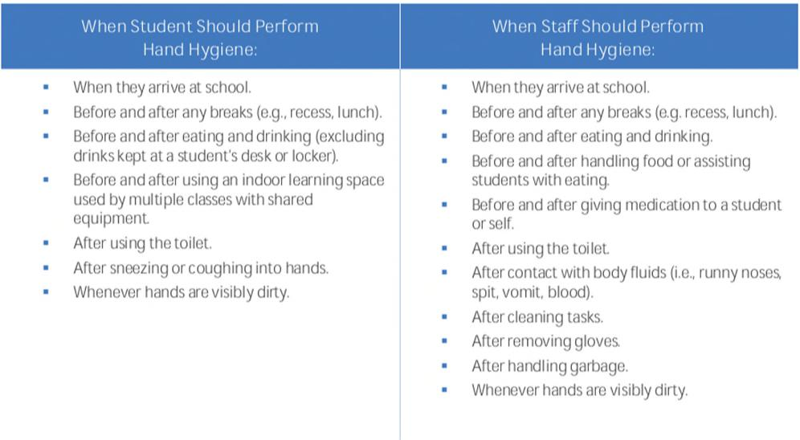

Hand Hygiene & Respiratory Etiquette

Hand cleaning facilities are available and accessible throughout the school and are well maintained.
Diligent hand hygiene will be promoted to staff and students regularly.
Personal Protective Equipment

Masks
Staff, adult volunteers, visitors, and students in Grade 4 and higher will wear a non-medical mask or face covering (a “mask”) according to the guidelines or applicable public health orders/recommendations. If wearing a face shield a mask is also required to be worn.
Grade K-3 students will wear masks based on their personal or family/caregivers’ choice. Masks are encouraged for K-3 students. Masks are available for those who have forgotten theirs.
Exceptions to the mask requirements for staff, students and visitor can be found in the Provincial COVID-19 Communicable Disease Guidelines for K-12 Settings – Updated August 24, 2021 on page 20.
Supportive School Environments

Personal Space
Strategies are in place to encourage staff and students to consider and respect others personal space. Personal space is the distance from which a person feels comfortable being next to another person. Physical distancing of 2M is no longer a requirement.
Public Health Measures

Attendance & Record Keeping
Staff and visitor sign in and confirmation of completion of the daily health check is required A list of the date and names for all visitors and staff who enter the school will be kept for 45 days.
Accurate class and bus lists will be maintained and kept for at least 45 days.

Environmental Measures

Ventilation and Air Exchange
All HVAC systems are operated and maintained as per standards and specifications, and are working properly. Filters have been upgraded and will be regularly monitored and replaced.
Use of portable air conditioners and fans in unventilated spaces with doors and windows closed should be avoided. Risk mitigation strategies are identified for excessive heat events or times of poor air quality.

Administrative Measures

Cleaning and Disinfecting
Cleaning practices will include:
- Frequently touched surfaces (those touched by larger numbers of people) are cleaned and disinfected at least 1x/day
- Surfaces touched by fewer people are cleaned 1x/day.
- Practices will be in place to clean and disinfect frequently touched surfaces when they are dirty
- Spray bottles in classrooms/offices for disinfecting
- Consulting with custodian.
- Other general cleaning occurs in line with regular practices.
- Practices are in place to clean and disinfect any surfaces a person’s body fluids have contacted after they have displayed symptoms of illness.
- Spray bottles in classrooms/offices for disinfecting?
- Consulting with custodian.

Gatherings and Events
School extracurricular and social gatherings and events (including those occurring within and between schools) are in line with those permitted as per relevant local, regional, provincial and Federal health recommendations and Orders. At this time, indoor gatherings are limited to 50 people or 50% capacity of the space.

Space Arrangement
During breaks and other unstructured time in indoor settings, strategies will be in place to ensure there is enough space available to prevent involuntary physical contact.
Staff Spaces Only
K-12 schools and other worksites will implement the following strategies: Utilize floor markings and signage to direct traffic flow and prevent crowding (e.g. in the break room, by the photocopier, etc.).
For gatherings (e.g. meetings, pro-d, etc.), respect room occupancy limits, use available space to spread people out, and consider virtual
options. Gatherings must also occur in line with those permitted as per relevant local, regional, provincial and federal public health
recommendations and Orders and any related WorkSafe BC guidance.
Visitors Access/Community Use
The front entrance door is unlocked. PLEASE NOTE THAT parents, QDL students and visitors must make appointments to enter the school.
Visitor access to schools may be restricted by local or provincial public health orders or recommendations from a medical health officer. See the Regional Differences section for more information.

Information on communicable disease protocols and requirements for visitors is posted by the entrance to the school and will be included in communications to students and families (facebook, website, direct email, and onsite signage).
Parents, visitors and guests will complete the daily health check, sign in and hand sanitize. Signing in confirms the daily health check was completed.
All visitors must wear a non-medical mask when they are inside the school. See the Personal Protective Equipment (PPE) section for more information, including exceptions to mask requirements for visitors (we will provide masks as necessary).
Where possible, visitor access should be limited to those areas required for the purpose of the visit (e.g. school office for drop-off/pick-up of items, gymnasium for a sports event, etc.) and should respect others personal space while on school grounds including outside.

Community use of school facilities is aligned with related public health guidance, recommendations and Orders. Safety plans are required
from user groups

Curriculum, Programs and Activities
For music and physical education (and other subjects as necessary), prevention practices specific to the activity can be found in the
Provincial COVID-19 Communicable Disease Guidelines for K-12 Settings – Updated August 24, 2021 on page 26.
Local day field trips are approved at this time. No overnight travel.
Local and international field trips will occur in line with those permitted as per relevant local, regional, provincial, and Federal public
health recommendations and orders for local and/or international travel.
Student Transportation
Masks: Bus drivers, adult volunteers and visitors, and students in Grade 4 or higher wear masks according to the guidelines or
applicable public health orders/recommendations.
Bus passengers will be spread out if empty seats are available.
Bus windows are opened when the weather allows.
Bus cleaning practices will include:
- Frequently touched surfaces on school buses will be cleaned and disinfected at least 1x/day.
- Surfaces touched by fewer people are cleaned 1x/day.
- Practices are in place to clean and disinfect frequently touched surfaces when they are dirty.
- Other general cleaning occurs in line with regular practices.
- Practices are in place to encourage bus drivers and passengers to practice hand hygiene before and after trips.
Carpooling - for carpooling related to school activities, students, staff and other adults must follow the mask requirements. Spread
out vehicle occupants as much as possible. Travel with the same people whenever possible. Hand hygiene before and after trips.

Food Services
Food and beverages should not be shared.

